請尊重智慧財產權請合法影印資料 Please consult intellectual property Rights before making a photocopy.

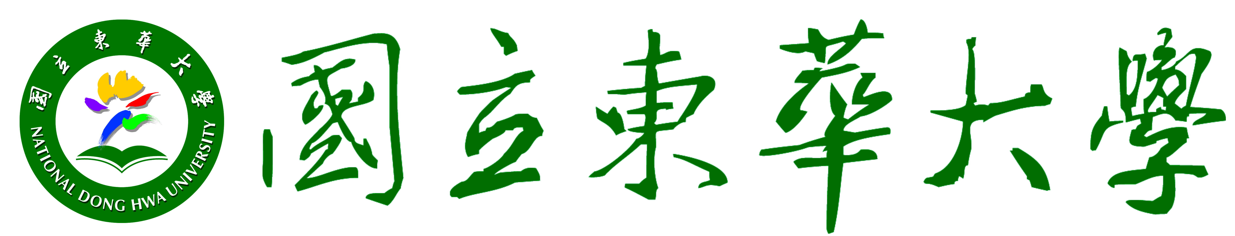
課 綱 Course Outline
中文課程名稱  Course Name in Chinese | 論文研究(二)
英文課程名稱  Course Name in English | Thesis II
科目代碼  Course Code |  | 班 別  Degree | ◻學士班Bachelor’s ◻碩專班 Master’s program  ■國際碩士班MBA ◻博士班 Ph.D.
修別  Type | ■必修Required  □選修Elective  □學程Program |  | 學分數  Credit(s) | 3 | 時 數  Hour(s) | 3
先修課程
Prerequisite

課程目標  Course Objectives | Thesis is a general education requirement, to be completed within a student’s major. It is intended to be a serious exercise in the organization and presentation of written material. Students select their own topics, in consultation with their faculty reader. Students pursuing honors within their major(s) should consult their department chair(s) for guidelines pertinent to the senior thesis requirement. Students are responsible for determining their departmental requirements.
系教育目標  Dept.’s Education Objectives | 培養具國際企業知識之高階管理人才。  Build a foundation of international business knowledge to prepare students for being managers. | 培養創新且傑出之高階管理人才。  Prepare students for being innovative and excellent managers. | 培養優秀國際服務業高階管理人才。  Offer a program with an emphasis on proficiency in management of international service business. | 培養在地經營理念之高階管理人才。  Offer a program with an emphasis on management philosophy responsive to the Taiwanese business context.
課程目標與系教育目標相關性Correlation between Course Objectives and Dept.’s Education Objectives | ● | ● | ◎ | ◎
圖示說明Illustration ：● 高度相關 Highly correlated ◎中度相關 Moderately correlated

系專業(基本）能力  Basic Learning Outcomes | A.具備國際企業管理之進階知識。  Students will have basic knowledge of international business.  B.具備邏輯思考、問題分析與解決之能力。  Students will be able to identify, analyze and solve business problems with logical thinking.  C.具備溝通協調與團隊合作之能力。  Students will be able to demonstrate effective communication, coordination and teamwork skills.  D.具備國際視野以及外語溝通的能力。  Students will be able to communicate in foreign languages and have an awareness of the global and cultural diversity issues.  E.具備跨國企業進階經營管理之能力。  Students will be able to demonstrate the necessary managerial skills for international business.  F.培養進階資訊科技運用之能力。  Students will be able to demonstrate proficiency in the use of information technology.  G.培養國際企業倫理之素養。  Students will be able to identify and understand the importance of ethical decision making for international business.
課程目標與系專業能力相關性 Correlation between Course Objectives and Basic Learning Outcomes | A | B | C | D | E | F | G
 | ● | ● | ◎ | ● | ● | ● | ◎
圖示說明Illustration ：● 高度相關 Highly correlated ◎中度相關 Moderately correlated

課程大綱
Course Outline

Here are some suggestions for the course Thesis II:
► modification of the drafts
► defense of the preliminary thesis draft
► resubmission of the modified version after the defense
資源需求評估（師資專長之聘任、儀器設備的配合．．．等）
Resources Required (e.g. qualifications and expertise, instrument and equipment, etc.

The thesis is a research paper and students are responsible, with the advice of their reader, for the investigation of sources, the accumulation of data, the selection of pertinent material, and the preparation of the thesis in acceptable form. Students submit their topics for thesis, with designated reader approval, at pre-registration or registration. All the students must choose a faculty reader who teaches within their major. Students are welcome to have an additional reader, if appropriate.
課程要求和教學方式之建議
Course Requirements and Suggested Teaching Methods

The following rules will be applied strictly:
1) Theses must be original work for this course only.
2) A thesis may be an expansion of a previous term paper; if so, however, an explanation must be included with the Thesis Topic Form and approval must have been given in advance by the Faculty Reader. Include the original paper as an appendix or in working papers.
3) All theses are carefully checked for originality. Students found to have committed academic dishonesty on their theses are subject to disciplinary measures through the Academic Standards Committee. If the act of dishonesty is a second offense, students are also dismissed from our school without the possibility of returning to earn a degree. You must learn the proper citation rules and scrupulously follow them. If you have questions about proper citation, make an appointment at the Department.
4) A thesis failed for any reason cannot be made up during the same semester.

課程成績評定之依據和標準
Grading Criteria

Students registered for a two-semester thesis will receive a grade and appropriate credit for the work completed at the end of the first semester (proposal defense) as well as a final grade at the end of the second semester (thesis defense). It is each student’s responsibility to find out exactly what the reader wants turned in at the end of the first semester (for Thesis I), whether an extensive outline, completed chapters, or chapter proposals. Normally students with two-semester theses will receive a grade (S-satisfied, or U-unsatisfied) and credit at the end of the first semester, as well as the same process at the end of the second semester.
其他
Miscellaneous

規劃單位：國企系
撰寫老師：欒錦榮

